# [Aws-EFS]

EFS is elastic file system of aws basicall it is a file where we share common dir between two different az’s

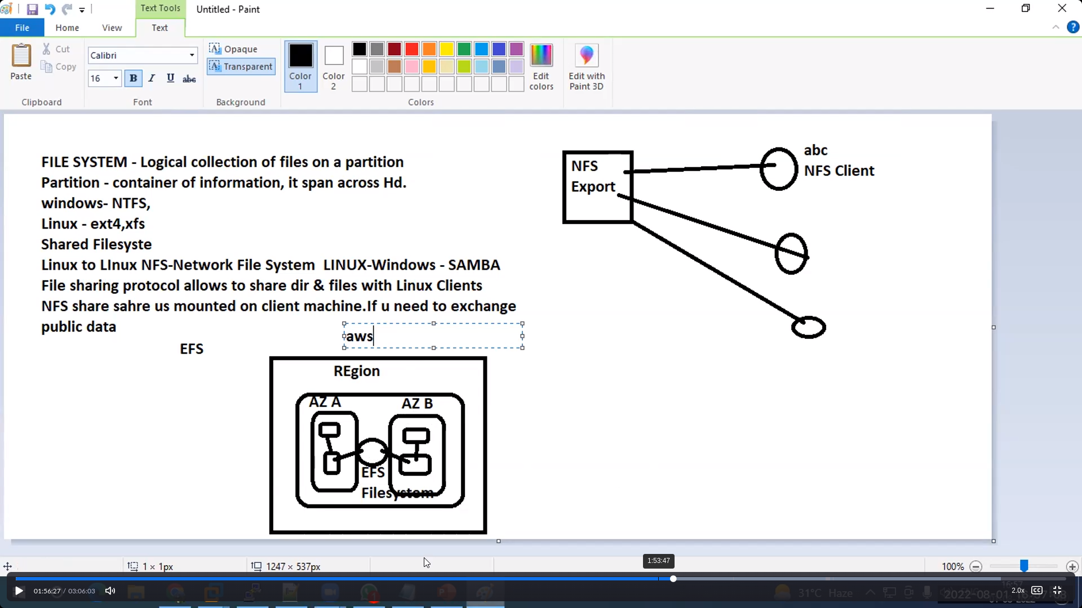

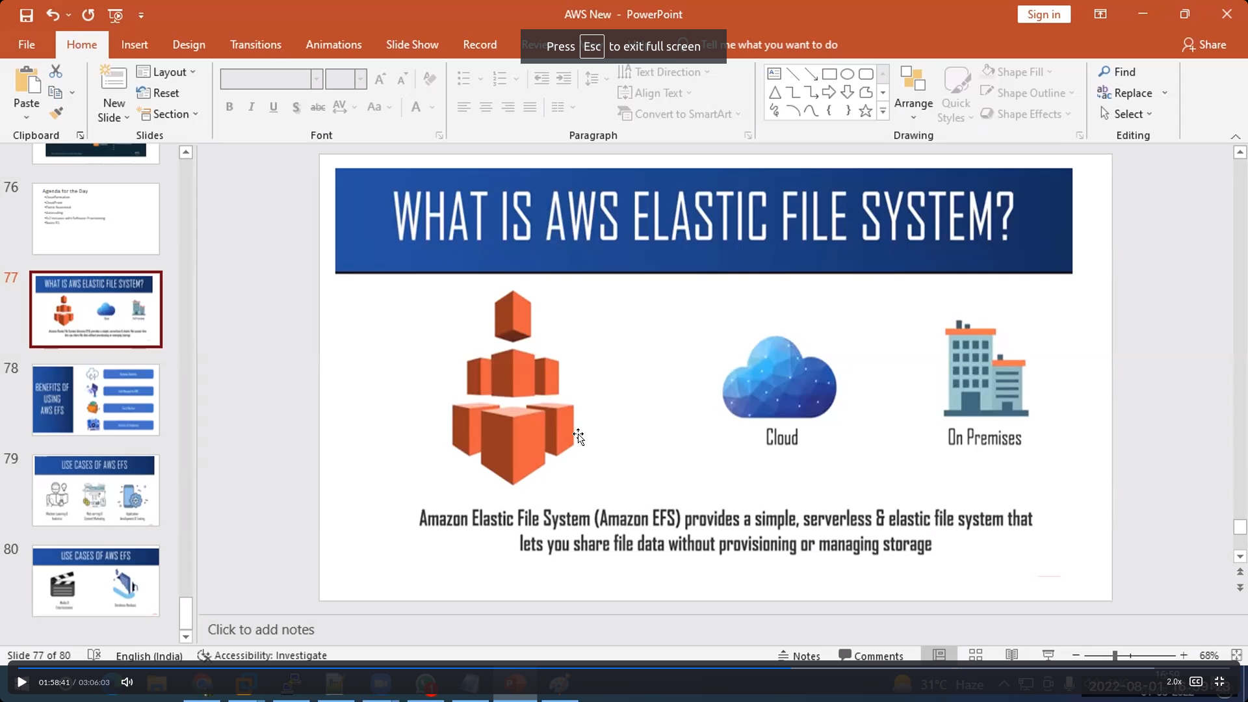

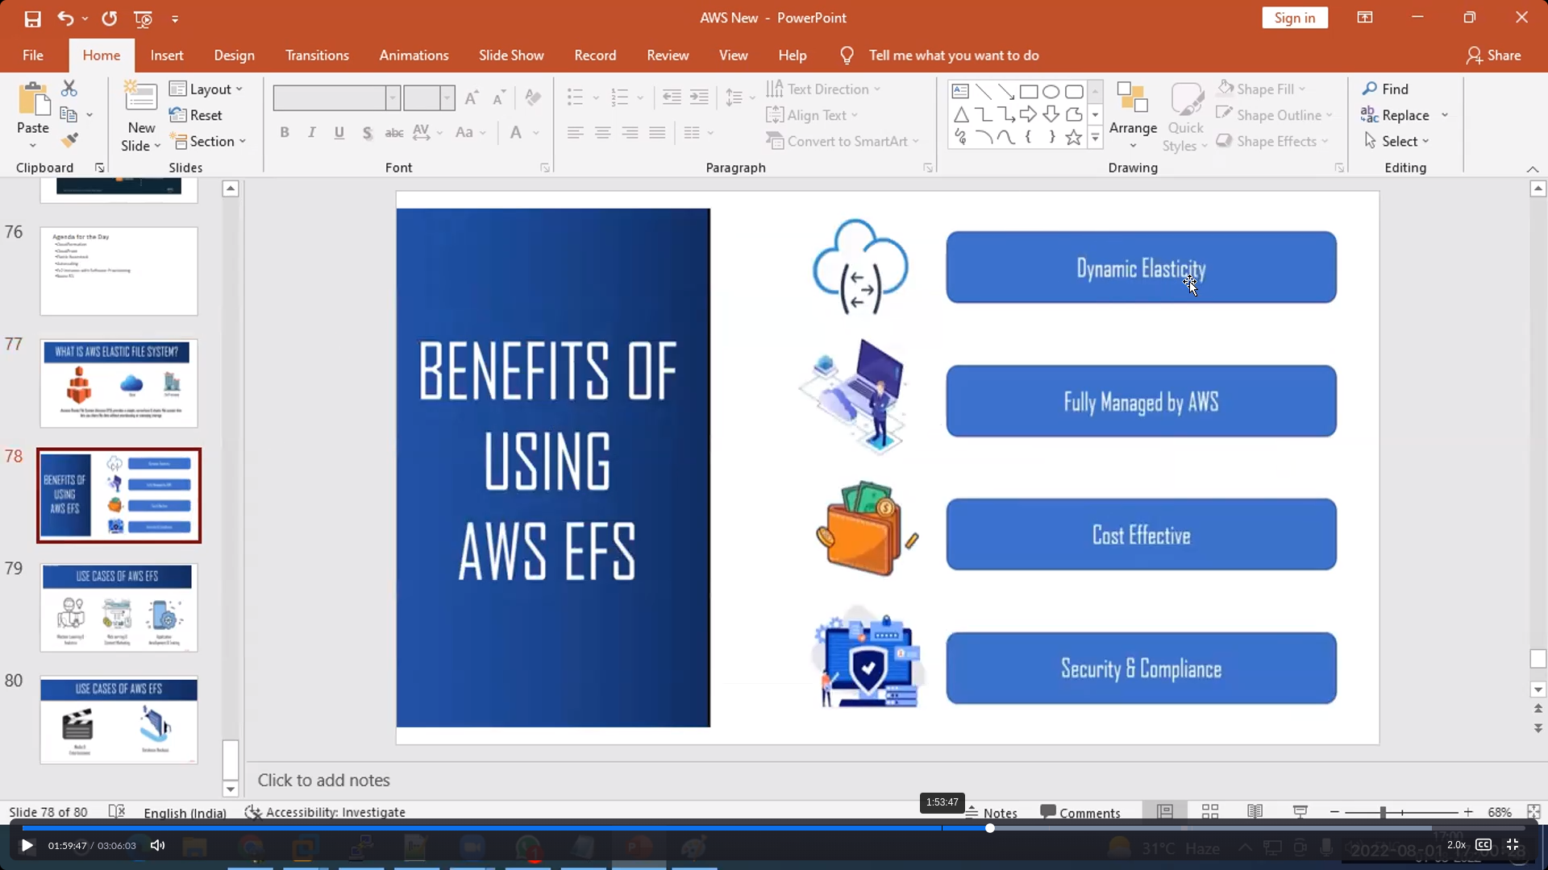

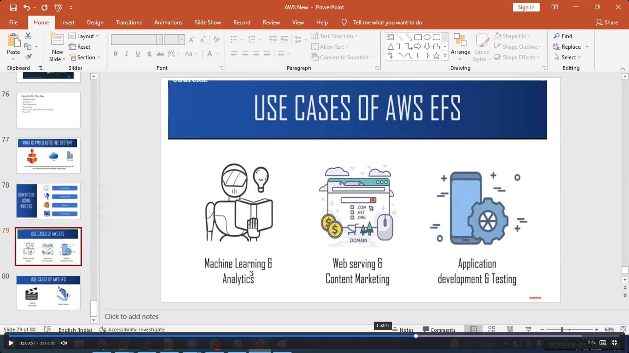

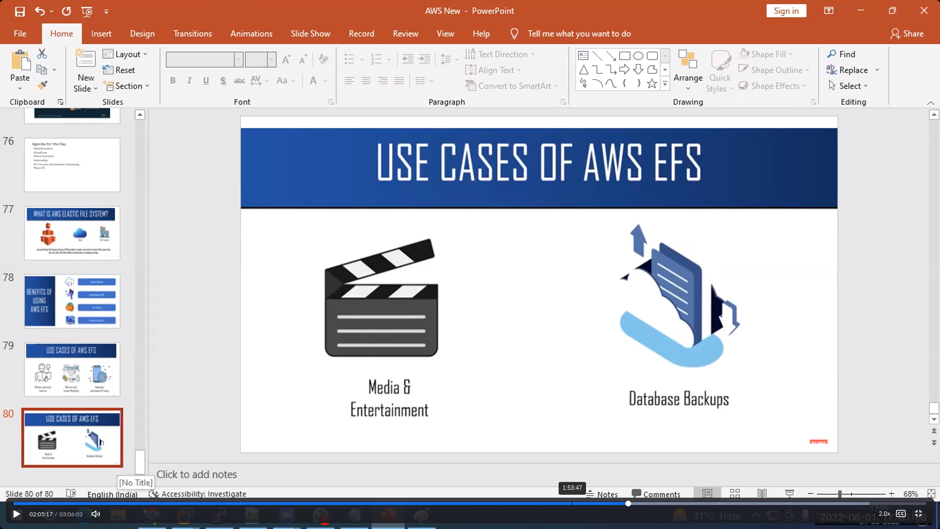

Steps:

1. Launch two instances

Cofiguration: different AZ’s and NFS to Anywhere in Sg’s

Intall amazon-efs : **yum install amazon-efs-utils –y**

**m**kdir efs in both instances

2. search for EFS-> click on createfilesystem

3. write your EFS Name

4. select default vpc

5. select standard

6.click on customize

7.uncheck the encryption of data at rest and click on next

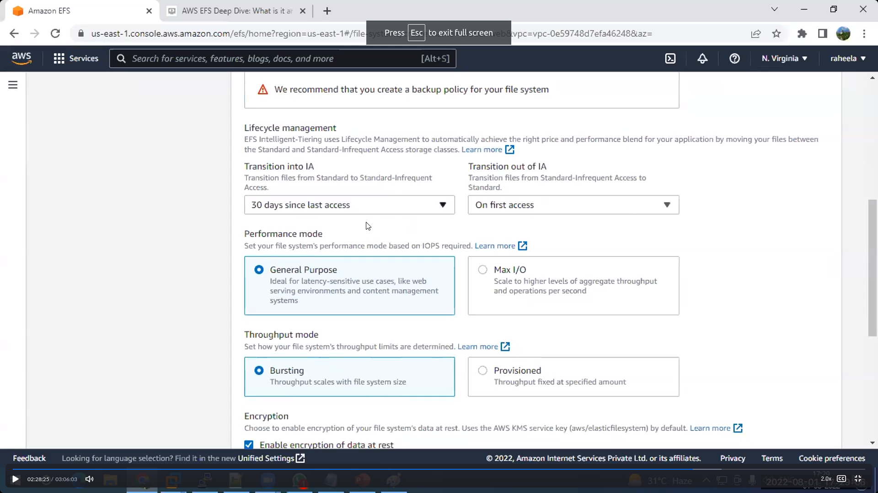

8.select the AZ’s and Sg’s of your instances

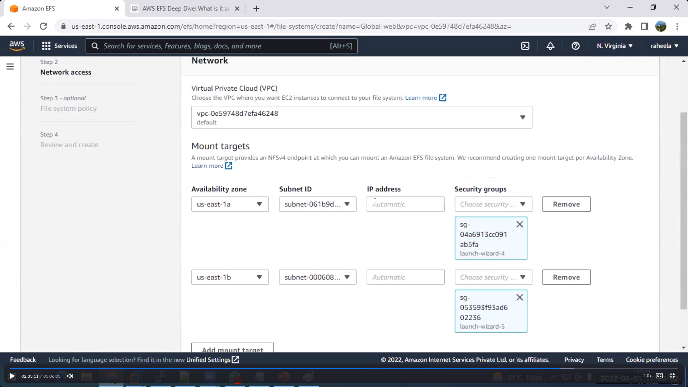

9. click on next ,next and create

10. Click on specific filesytem id

11. Click on attach

12.copy the first command

[ex: sudo mount -t efs -o tls fs-0bc18c1ca624b8d57:/ efs]

13. Execute the command in both instance where created the directory

14. Try to create some files in one instance it will reflect in another instances